I got an email from campaign team, what should I do
Identify the type of email received from the campaign team. It could be an inquiry email or a confirmation email.
2. If it's an inquiry email:
- Check with the supplier regarding the lead-time and related material.
- Identify any potential bottlenecks and raise them immediately.
3. If it's a confirmation email:
- Check the required quantity against the normal call off.
- If the required quantity is greater than the normal call off, send a separate email to remind the supplier about the sudden increase in quantity. Raise any issues if necessary.
- If the required quantity is less than the normal call off, check if the current stock covers the required quantity or if an extra call off (considering MOQ/Load unit) is needed.
- If one-way packaging is needed (adapted for container loading), the campaign coordinator will specify this in the email.
4. Always use appropriate terminology when communicating with the supplier and internally.

What is an ACF2ID?
An ACF2-ID is a unique identifier used within the PULS system. It is used to manage access and permissions for individual users. This ID is crucial for maintaining security and ensuring that only authorized individuals have access to certain information or functionalities within the system.

Add, delete, or change an email address on a report generated from W8 library / automatic library.
Log in to VICS, open ML in the list or Write ML = member library on the command line, write W8 on the high index line, IC on the Group line, JCL on the TYPE line and press enter. The program list shows Easytrieve + (E+) programs made to create reports. These reports can be set to printed or mailed.
These programs are started from another program in the list. Those are usually named started with AAA. Example AAADAY for programs that is started daily and AAAWEEK that is started once a week.
You can search for a mail address if you write “Search (or sök) + mail address” on the command field if you are entered W8, IC, JCL.
To sort the program list after the search. Set the marker on Prompt and click. The list is now sorted to show programs that include what you search for.
If a line is marked as “*Found” the search found something, and you want to change something in the program, write E (means EDIT) before the program name. Click Enter.
You can search values in the program by writing FIND and the value that you want to find.
F5 is a button that is good to use here.
If you want to remove a line, set a D on the numbers on the left side of the line that you want to remove.
If you want to add a line, set a I (for insert) on the numbers on the left side of the line that you want to add.
If you want to edit a line, edit the line.
Press F3 to save.
F3 several time to close.
How can you correct a wrong OKS or OQB value
For OKs and backorder balances, it should also be stated whether it is VOR (V), Day (D) or Bulk balance (B) that is to be adjusted (for backorder balance, only D or B can be entered for NDC's). It may be helpful to look at picture 0510 to know which type to adjust.
To check if there really is an OKS, you should look at 4509. Blank out (space) both district and customer and fill in the article number. If there is an order there, this number should remain (on the correct order class).
Refill ordered in the picture
Reserved Quant (Res quant in the picture)
To be filled in at the next correction
Backorder balance (Stay in the picture)
To fill in at the next correction
Instruction
Go to slide 5166. Enter the part number and the DC where the balance is to be adjusted.
Press enter.
Enter "+" or "-" if the number is to be increased or decreased, and enter the number in the column "Qty" for the balance to be adjusted.

What is the LDC concept and what is pre-planned / repair order and which order classes are used for those
The local distribution concept is a way of organizing the spare parts supply chain to provide fast and reliable delivery to the dealers. The concept involves using a network of local distribution centers (LDCs) that store a large assortment of parts and can deliver them to the dealers within 24 hours or less. The LDCs are replenished by the central distribution center (CDC) based on the demand from the dealers.
- Reduce dealer inventory to a small fraction. The dealer only needs to keep a minimum stock of parts that are frequently used or critical for customer satisfaction. This reduces the capital tied up in inventory and the risk of obsolescence.
- Excellent parts availability (99.5%*) due to the possibility to secure availability further up the supply chain – from CDC to LDC. The dealer can rely on the LDC to provide the parts needed for pre-planned or repair orders, without having to worry about shortages or delays. The LDC has a high fill rate and can handle fluctuations in demand.
- Reduces repeat repair. The dealer can avoid having to reschedule appointments or send customers away due to missing parts. This improves customer satisfaction and loyalty and reduces the cost of rework and warranty claims.
- Creates new opportunities for additional repairs and sales. The dealer can offer more services and products to the customers, such as maintenance packages, accessories, or upgrades, knowing that the parts will be available when needed. This increases revenue and profitability for the dealer.
- Frees up space and personnel to expand business. The dealer can use the space and resources that were previously allocated to inventory management for other purposes, such as expanding the workshop capacity, displaying more vehicles, or enhancing the customer experience. This can help the dealer grow its market share and competitiveness.
- Workshop efficiency (rational process, smooth workflow). The dealer can optimize the workshop operations by planning the work orders in advance and having the parts ready when needed. This reduces the waiting time and downtime for the vehicles and the technicians, and increases the productivity and quality of the service.
- Repair orders (or pre-planned order) are used for a repair or service for one car. We use order class 3 and on some markets order class 2 for these.

How can I change who will receive a mail from a control (inspection) report, example if someone has changed quality contact on screen 6221?
The email addresses for inspection reports is set in PULS distribution module called Distribution & Print (in short D&P). The mail address can be viewed on screen 6221.
There are 4 different rules:
W42625-001 begins with SERA (admin) and then the supplier number
W42625-001 begins with SERT (technical / quality) and then the supplier number
W42655-001 begins with SERA (admin) and then the supplier number
W42655-001 begins with SERT (technical / quality) and then the supplier number

How do I change rules and/or addresses in D&P
Background:
In order to be able to send documents and print out and/or send e-mails, it is necessary to set up rules in PULS and in Distribution and Print (D & P)
Which e-mail addresses these documents should be sent to is controlled by Distribution & Print.
Routine:
If you also want to be able to send the documents to e.g. a carrier, then rules must be posted in D&P per document.
Log in to D&P using same link as WEB PULS, click on Volvo Cars in the top / General / Distribution & print.
Tap on Distribution Rules and Locate rules.
Below is an example and description for the shipping document.
Fill in the document name in the Output type box, DC in Sub type or prefix and press Search.
The document name is taken from picture 4456, it always starts with shipdoc and then an abbreviation of the name. For example. Cargo specification becomes shipdoc-cs.
Now you need to enter the rule in the right place.
Scroll down to the district number range that the new district fits into.
Press the blue arrow in front of the row.
Now you create a new rule just for the district and the document.
Fill in the DC and district to and from.
Select E-mail, fill in the address, lay out definition and Carr cntl included.
Update with the insert button.
Press search and scroll down to the newly entered rule.
Now you have to change the rule that already includes the district.
Press the blue arrow in front of the rule you want to change.
Change to the district and update with the Insert button.
Press New Search and scroll down again to the incorrect rule.
Now the incorrect rule must be removed so that the district rules are in order.
Press the blue arrow in front of the highlighted rule.
Delete the rule by pressing the Delete button.
Press New Search and scroll down to the location where the new rule is located.
Now the incorrect rule is gone and all the district's rule lines are in order.
Repeat the procedure if another shipping document is to be sent by e-mail. Start by filling in the name of the document in Output type and press Search.

I need more access in the PULS system
Modify and clarify this info: (HD)
To get more access in the PULS system, you need to follow the established process for requesting additional user rights. This typically involves:
1. Identifying the specific access rights you need. Be as specific as possible about what you need to do in the system that you currently can't.
2. Getting approval from your manager. Your manager will need to approve your request for additional access rights. This is to ensure that all access is properly authorized and necessary for your role.
3. Submitting a request to the IT department or the team responsible for managing user access in PULS. This request should include your current user information, the additional access rights you're requesting, and your manager's approval.
4. Waiting for your request to be processed. The IT department or responsible team will review your request, make the necessary changes in the system, and notify you when your new access rights are ready to use. Remember, all access rights in PULS are granted based on the principle of least privilege, meaning you should only request and be granted the minimum access necessary to perform your job duties.
Check volume or/and weight from DDGS
DDGS DESADV includes the weight and volume that we set on the shipping documents. Please check the DESADV in GEBIS to control what the supplier sent.
You can use the PULS production number (can be seen in PULS screen 4501) as document number to search for the correct DESADV.

How do I find a report to edit an email address if i only have an email address
Reports are created in several modules and applications.
One place to check is the "automatic library" for E+ reports located in IBM mainframe VICS, go into function ML = main library. Type in Hig index = W8, Group = IC, Type = JCL. Press enter.
In the command field, write search + a part of the email address and press enter.
Set the cursor on the P in prompt and press enter and the list will be sorted. If you get a message *Found the value that you searched for is in that E+ program. Open it with E = EDIT + enter
Find the correct line in the program and edit.

Return permission is stucked due to partnr 100 have an "R" instead of "J" on screen 4712
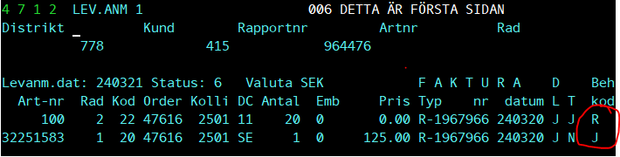
Send a request to BA first and then it goes to developer for assist since change in program is needed.

How to set permissions to access a private E+ (easytrive+) / VICS library.

To be able to set permissions you have to login with the user id that shall be accessed.
Go into VICS
On the command line, write FILSEC.
The screen shows who can access your library. ID per ID or you can use All (ALLA på Svenska)
The access levels are READ and WRITE or all.
If you want to give access, write the ID that shall access and write X on Read, Write and All depending in the access you want to give. Enter to submit
Close and save with F3

Which order classes are used in PULS and PS&L

Order Class 0:
Description: This is typically used for emergency also called VOR = Vecicle of road or very high-priority orders.
Handling: These orders are processed immediately and are given the highest priority in the system.
Delivery: They are often shipped using the fastest available method to ensure quick delivery.
Order Class 1 = Day orders
Description: This class is used for high-priority orders that are not as urgent as Class 0. Handling: These orders are processed quickly but may not be as expedited as Class 0 orders.
3. Order Class 2: - Description: This class is used for standard orders that do not require expedited handling. Can also in some markets be used as repairorders with short leadtime to the repair date.
- Handling: These orders are processed in the normal workflow. –
Order Class 3: - Description: This class is used for bulk orders or orders that are less time-sensitive.
Are also used for repair/preplanned orders-
5. Order Class 4: - Description: This class is used for replenishment to refill and retailers orders, which are orders placed to replenish stock at distribution centers. - Handling: These orders are processed based on inventory levels and demand forecasts.

What is VR?

VR is an application that supports our dealers / retailers with the stock replenishment. VR shall not be mixed up with VOR.

Who to contact if there is any questions about VR application (VR = Volvo reservdelar).

Please send mail to support.vr@hcl.com

How does the application calculate Ready for shipment date and time for preplanned / repair orders?

Preplanned orders shall have a repair date. The calculation is based on the repair date and when we need to start produce it.

Use screen 4413 and Calender screen 4369 to calculate.
On screen 4413 DC = “Default” what RFS from facing DC “repair date” minus “the qty of RFS date calc”
On screen 4413 DC = “11” what RFS will be in case of referral from DC11 “repair date” minus “the qty of RFS date calc”

I can’t find this case on 4663/ start transport. Where is it?
First check if case is already loaded. Use TRP no on screen 4666 / Transport not closed.
If the case is DC SE. Please check if case is received on screen 6175. You can also check on screen 4347 what TRP the case is on, if case is received and not loaded. And if it is a mixed case, see it the case is closed on screen 4344.

Why did I get the wrong RFS for my order?
The order always look after a Transport-ID that has a departure date and time. Search for the trpid on screen 4582. Departure time (minus) loading time - and / or - admin time = RFS-time.
If the dealer does not have a specified TRPID on screen 4417 it will fall into the default line and take that TRPID.
How does RFS work?
The order always looks after a Transport-ID that has a departure date and time. Search for the TRP-ID = Transport ID on screen 4582. Departure time (minus) loading time - and / or - admin time = RFS-time.
If the dealer does not have a specified TRPID on screen 4417 it will fall into the default line and take that TRPID.
You also needs to take the lead time from screen 4415 in consideration. departure time (minus) lead time is the cut off time. If the order was placed after the cut off time, the order will look for the next departure.
How to add access to create transfer orders for ESC = External supply control?

On PULS screen 0801, add an ESC number and fill in the information. OBS, in the email value field just set everything before the @. Save with F11

After the save the emailaddress will be prefilled with @Volvo.com. Change to the correct and save.

After the ESC number is assigned on 0801, connect the users PCID with the ESC number on 0514.

What is included in the case id and order id when PULS send data to the package data/service layer?
Package id and PULS order id:
PULS order ID sent to Package data/service layer consists of district + customer + order + date DDDDCCCCCCOOOOODDDD => 4+6+7+6=23 positions
PULS case id consists of district + customer + order + date DDDDCCCCCCOOOOCCCCC => 4+6+7+5=22 positions.
When we send packages from PULS to the package service layer, we send with both of these identities. Note! that in the case of backorders, a new order header is created, which leads to the parcel time being sent with the new order number, but the order id remains the same, i.e. the original order number.

How do I cancel an order in R (registered) Status?
Go to screen 4204. Fill District, Customer and order number + DC.
If you want to cancel the whole order set Y = yes for the whole order. Update with F11
If you want to cancel just one line, set D on the CMD line. Update with F11.

How do I cancel an order in P (printed) Status?
Make sure your Profile is set on DC11 (change on 0511 if necessary)
Start with page/screen 4357, fill in District, Customer, order number or production number. Enter.
Note the Order part number (Ln on the screen), packer id (and production number)
Go to page/screen 4312, fill in packer id, Dist and production number. Enter.
Change packer ID to 0, fill on 0 in the column for new packer. Press F11 for update.
If you get an error message that says something like that ”the packing sequence is not ready”, you need to go to screen 4318, fill in all necessary values, press enter, set control to N = NO and press enter. Star again at screen 4312.
The printed order can now be cancelled at screen 4359. Fill District, production number, Order part number (PLKLST on the screen) + DC,
If the order is presented you can choose to cancel whole order, part or a qty. Fill in press F11.
If the order is cancelled there is info in the bottom of the screen

What does the different Cust Category in PULS customer table means?
On screen 4411 you can add customer category. The category tells what type of consignee it is.
1 – Dealer
2 – Polestar
3 – Lynk & CO
4 – Importer
5 – Internal customer
6 – Sales company
7 – Supplier order, when a supplier orders from PULS.
8 – Refill
9 – Transfer
10 – Extended refill
11 – Returns
12 – Quality returns
13 – Scraps
14 – Quality scraps
15 – Mixed stock, it is used when stock is adjusted between two warehouses.
16 – Internal exchange order
17 – Emballage
18 – Ecommerce

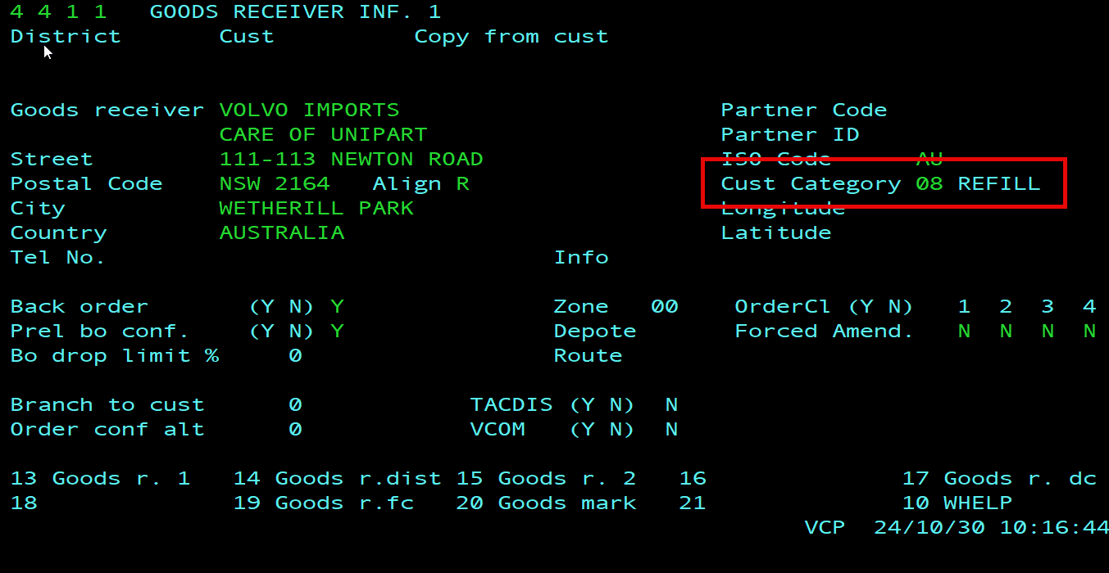

Issues with creating a transfer order?
For summerworker or new employees the most common issue is that 0514 is not update with ESC as job role. If the user has an esc account the number is usually added here as well, but not mandatory.
The actual job role (ESC in the red square) will suffice. The roles that exist for this purpose is VOR, LOC and ESC. LOC should be used for North America users.
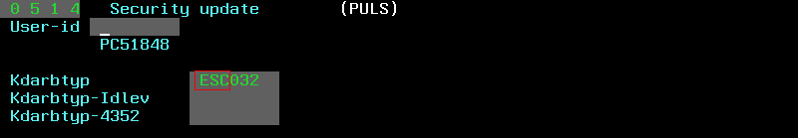

If this is updated the most common problems are that the user is not using the session first logged into PULS. Can either be on a different session/window or even laptop (good last question to ask if the users has changed computer).

